Qualtrics Assignment: Create a sample survey

Instructions:

1. Please create an account in Qualtrics. (see ‘A’ below)
2. Watch the following introductory short videos on how to create surveys using Qualtrics.

<https://www.youtube.com/watch?v=_hSo-ldj19k>

<https://www.youtube.com/watch?v=MP6jTcHU_5w>

1. Create a survey that has the following components:
   1. Consent block – with a forced question and skip logic to end survey if answer is no.
   2. Block with 2 questions: (1) yes/no answer, (1) multiple choice -5 or more
   3. Set up distribution such that you create an “anonymous link” to the survey. You will need to select the anonymous link option in the distribution window.
   4. Please submit the anonymous link in Blackboard
2. Create an Account in Qualtrics:

**Creating an account in Qualtrics – CPP Procedure**

Go to: <http://cpp.qualtrics.com/>

Log in with your bronconame and password

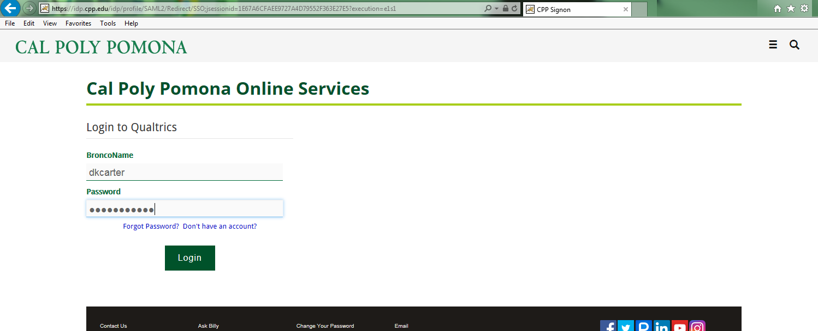

Select **I don’t have a Qualtrics account**

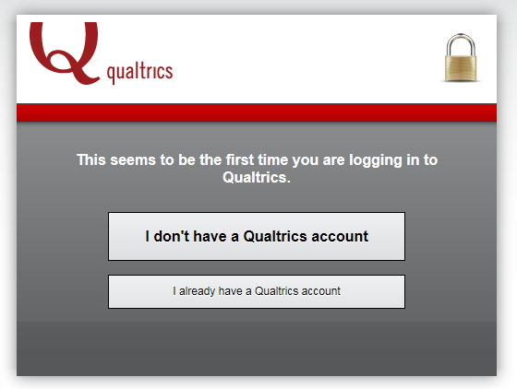

Read and **accept** the Terms of Service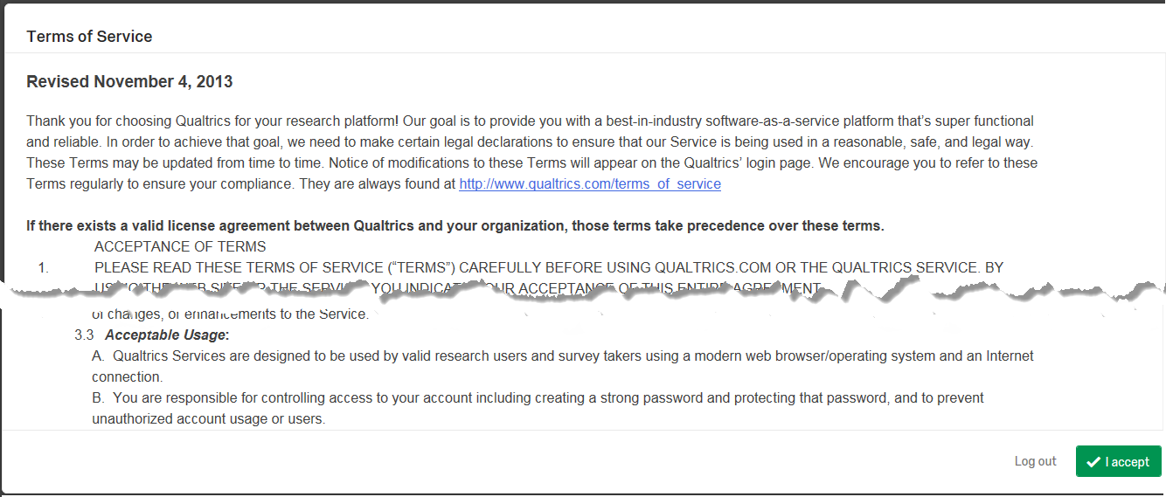

This will set up the individual as a general cpp user – in order to create their college account

Select **Cancel** (located at the bottom right hand corner)

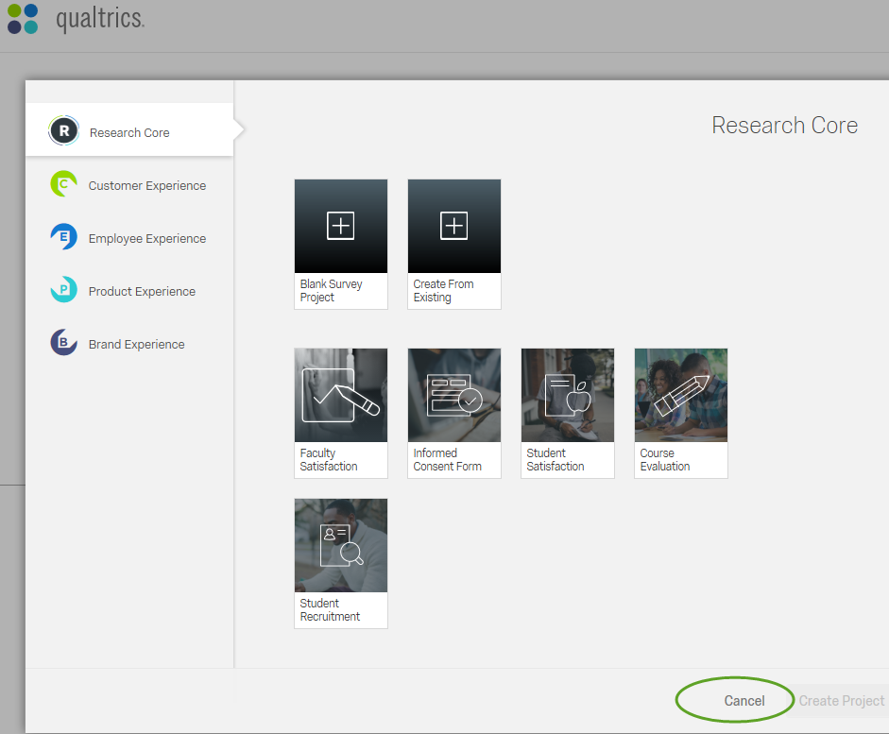

Select the **My Account** icon – located in the top right hand corner

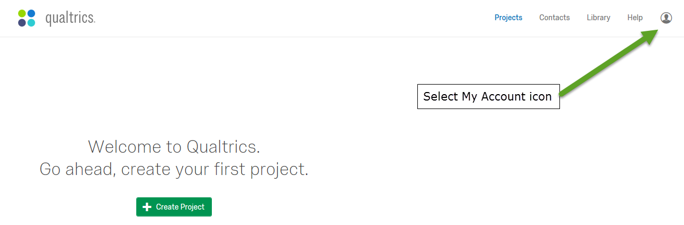

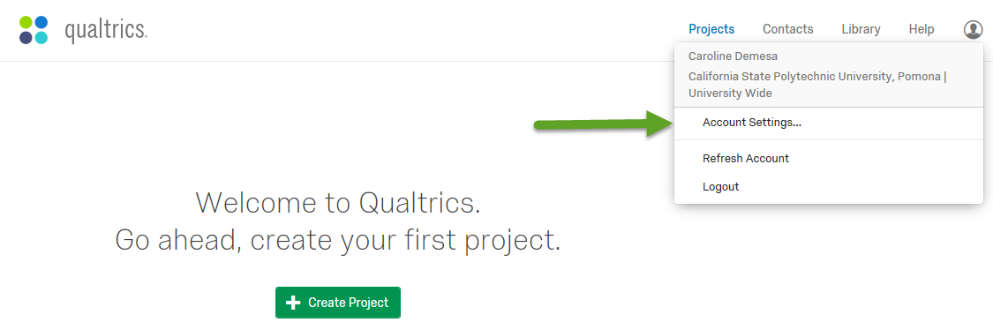From the dropdown select **Account Settings….**

Select **Upgrade Account** and type in the upgrade code: CLASSstudent

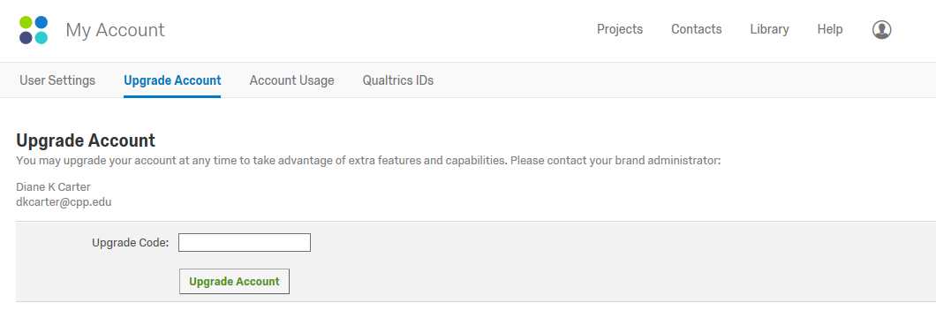

And select **Upgrade Account** below the Upgrade code box

Unfortunately, the system doesn’t look like it did anything but it did. Select Projects at the top right and continue on.